From the Pastor’s Cup…כד
June 2023
Dear Church Family,
Will Rogers, the great American humorist, had an attitude toward humor different than most of the humorists today. I would like to share one of his thoughts with you this month.
This is what Will Rogers thought about the American Spirit, “This country is not where it is today on account of one man. It is here on account of the real common sense of the Big Normal Majority.” –Will Rogers Wise and Witty Sayings of a Great American Humorist, page 7.
I long for the return of the Big Normal Majority when politicians practiced compassionate, considerate, and compromise politics. I think Will Rogers next wise and witty saying is more true than ever in our nation and politicians who seek to divide us to conquer us,
“If you can start arguing over something, and get enough publicity, and keep the argument going, you can divide our nation overnight as to whether spinach or broccoli are the most nutritious.” –Will Rogers Wise and Witty Sayings of a Great American Humorist, page 7.
Somewhere we lost the ability to agree to disagree with mutual respect and grace. I like both fresh spinach and broccoli so I hope you don’t look down on me or think less of me for that. I know there are those who don’t (like spinach or broccoli). When our children were little, we couldn’t get them to even look at a green vegetable let alone eat a green vegetable. But now, that they are in their late 30’s and early 40’s, they do! I remember looking at our son, Mike, when he was eating a fresh green garden salad with blue cheese dressing, thinking, “Who are you? And what have you done with my son?”
I suppose a sign of maturity is a mature palate that embraces ALL of God’s good Garden of Eden creations. This is my way of announcing that on Sunday, September 24, 2023 our Mission Sunday speaker will be Simone & Matt Weber from Table Grace Café located in downtown Omaha, NE. Not only will Matt and Simone be here, but they will also be bringing their Table Grace Café Food Truck to serve burgers and brunch after worship at the very reasonable price!
A food truck for all! Mobile Grace Café is taking Table Grace’s mission on the road. “Nourishing Hungry bodies and souls through music” is our vision and calling. We do this by offering food made with the highest quality ingredients and culinary standards to all who approach our truck or café whether they are able to pay or not.
Our mission states we work “To foster a healthy community by offering great food prepared and served with dignity and to provide opportunities for transformation both personally and spiritually through hospitality, music and fellowship.”
Please mark your calendar with this time and date: 10:00 a.m. Sunday, September 24, 2023 to meet Simone and Matt Weber and the Mobile Grace Café. Simone is a PK (pastor’s kid) who will also be sharing her musical gift with us, but I’ll tell you more about that next month!
Sincerely Pr. Jer
Tools for Your Spiritual Toolbox There is a long history of meditation in the Christian faith. In the Bible, there are numerous verses about meditation on God’s Word and God’s works, even in the first verse of Psalms:
Happy are those
who do not follow the advice of the wicked,
or take the path that sinners tread,
or sit in the seat of scoffers;
but their delight is in the law of the Lord,
and on his law they meditate day and night. (Ps. 1:1-2)
For three Sundays (June 11, 18 & 25) before worship time at 9 am (8:15 to 8:45 am) we will gather in the in the Fellowship Hall to experience some Christian meditation practices like reflecting on a scripture passage using breathing techniques. Come and take part, you just might add a new tool to your spiritual toolbox!

Pastor’s June Calendar June 2-3 ELCA Nebraska Synod Assembly @ Kearney, NE June 6 Text Study June 9-10 Abby Mason & Heath Hovendick rehearsal/wedding June 13 Text Study June 21 Text Study June 23-24 Jamison Theye & Mason Roth rehearsal/wedding June 26-July 2 Vacation
Zion Lutheran Church Council Minutes May 3, 2023
Meeting was called to order by President Alan Folkerts
Members present: Kristi Dorn, Cindy Parde, VeAnn Jurgens, Carrye Meints, Neal Meints, and DeAnn Oltman
Absent: Brenda Gronewold
Pastor Jer shared: Regroup & amp; Reflect –
Motion made and seconded to accept meeting agenda for 4/5/2023 meeting.
Upcoming Baptisms:
● 05/28/2023 – Baby girl Sturek (Kelly &amp; Brittany (Bohlmeyer) Sturek
6/25/2023 - Everlee Mae Glynn, Josh &amp; Sabrina Glynn

Upcoming Weddings:
● 06/10/2023 -- Abby Mason &amp; Heath Hovendick
● 06/24/2023 – Jamison Theye &amp; Mason Roth
● 9/16/2023 - - Dale Hrenchir &amp; Hannah Ley
● 10/21/2023 – Trip Cornelius &amp; Amya Beach
February Mileage: 813 miles
Celebrating God’s Work in Progress – Old Business
● Picture Directory –Ordered the website. Pictures are organized and matching names to pictures
in alphabetical order. This will allow us to put in the pictures in the future. $79 for the year.
When it is finalized, we will take to a printer in Beatrice and have copies made. It is up and
running and easy to use.
● Doors - Getting a bid for 6 panel door, steel door, and a smooth door.
● Baccalaureate - Freeman, May 10, 2023, at 7:00 p.m.
● Tuck Pointing - Doors – Still looking into bids. Checking into steel doors.

Discerning God’s Will – New Business
● Vacation Bible School - Everything is ready to go. May 30-June 2
● Time Change of Service - 2nd Week of June to start at 9:00 a.am.
● Laptop Computer - Checking into one for the services to use.

Ministry Team Report as of 4/5/2023
● Financial-General Fund-Balance on hand 4/1/2023 $116,951.21
Income- $20,326.04 Expenses- $20,038.53
● Balance on hand- 3/31/2023-- $117,238.72
● Sinking Fund - $54,558.93
● Seminary Fund - $40,957.10
● Thrivent Mutual Funds - $2,737.64
● Open Savings - $25,051.79
Motion was made to approve the Financial and Ministry Team reports.
Next council meeting will be Wednesday, June 7, 2023.
Devotions – 7:00
Committees – 7:05
Council – 7:30
We closed with the Lord’s Prayer
Respectfully submitted, Carrye Meints, Secretary

COMMITTEE REPORTS
ENDOWMENT COMMITTEE: Did not meet.
Treasurers Report - $ 213,223.13

HOSPITALITY: Did not meet
Graduation Recognition May 7th
Will look at doing something around Father’s Day in June

MEMORIAL COMMITTEE: Did not meet.

PARISH ED Members Present: Heather Hippen, Kate Meints, Nicole Behrends, Allison Lane &
Lanette Nelson
Members Absent: Jay Bartlett
- Balance on hand as of 5/3/23
  - $2,500.61
- Old Business
  - VBS Thrivent Grants - Eddie & Lynette Dorn agreed to do a grant for snacks and Brooke Jensen for craft supplies.
  - Sign up station for volunteers and donations has been set up in the fellowship hall. (All spots have been filled for volunteers- Thank you!)
- New Business
  - We are currently looking for Sunday School teachers, specifically 7th grade at this time as Doreen Remmers has resigned from teaching.
  - We are always looking for substitute teachers for Sunday School. Please reach out to any Parish Ed member if you’re interested.

PROPERTY & MANAGEMENT: Neil Meints, Alan Folkerts, Kenny Reed
Minutes approved as read.
Treasurers Report – N/A
Old Business –1. Alan Folkerts getting quote for doors for fellowship doors.
For raised panel wood
With smooth wood
For metal doors.
2. Alan Folkerts will ask stainglass contractor to speak at
quarterly meeting in July
3. Need to get drywall repaired by elevator painted.
4. Need floor tile by west fellowship door repaired.
New Business- Talked about hot water situation in church with smell. Asked
Lammel to price a tankless water heater.

Park Board: Members present – Paul Jurgens, Greg Robinson, Doug Davison, Terry Oltman, Kenny Reed.
Treasures Report 5/2/23 – Checking $ 6,213.80 Savings - $ 4,202.26
Old Business: batting cage – still owe $10 K – final cost will be approx. $35 K.
Banners – when weather permits
Schedule/calendar

New business: old well – need to drop chlorine tablets in well south of parsonage.
Have ice machine connected.
Annette Wiese met w/concessions crew and have a schedule.
Received donation from Jameson Wallman - $1000
Sprinklers are fixed.
Hamburger donated by Wade Thornburg ¼ beef.
Get screens replaced on concession stand windows.
Donations for remodel of women’s bathroom $8K

Publicity: Did not meet

STEWARDSHIP: Did not meet

WILLIE & ANNA MEINTS ENDOWMENT: Did not meet.

WORSHIP & MUSIC: Alnora Daubendick, Shirley Gronewold, Carrye Meints
Picked hymns for May and June
.
YOUTH: Did not meet

Grace Circle News
Grace Circle met at Valentino’s in May for a luncheon for their May meeting. No business.

June Grace Circle will meet June 14th at 1:30 pm at the Fellowship Hall
Opening/Scripture & Prayer will be Given by Alnora Daubendiek
Bible Study: Alnora Daubendiek
Hostess: Lois Meints

Stop by the Welcome Center and get your copy of the Expressions for May

Our Sympathies

Our deepest sympathy to LaDonna & Darwin DeBuhr on the death of LaDonna’s mother Arlene Kelle. Arlene passes away Saturday, April 29th and the funeral was Thursday, May 4th at St John’s Lutheran Church in Beatrice. Arlene was also the grandmother of Neil & DeAnn Smith, and Miranda & Curtis Meints. Please keep these families in your prayers at this time of loss.

Our deepest sympathy to the family of Elsie Zimmerman – Elsie passed away on May 20th at the Homestead House. Elsie’s funeral was Wednesday, May 24th here at Zion. Please keep the family in your prayers at this time of loss.

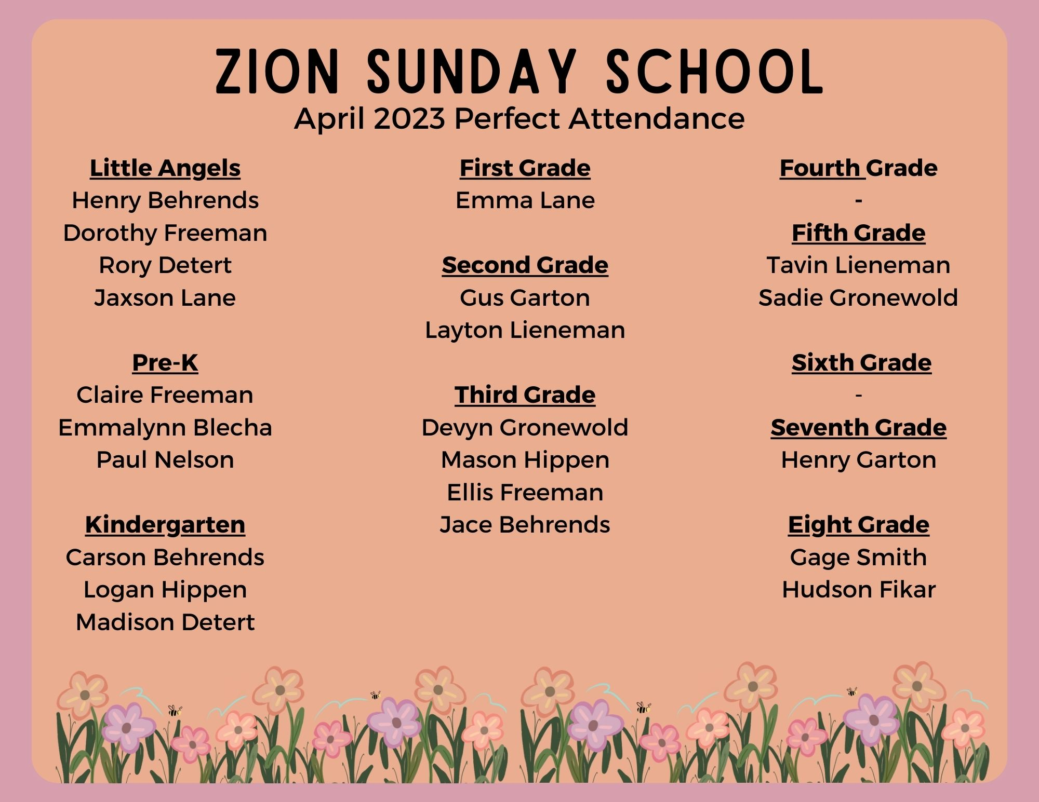

Zion 2023 Graduates
Camden Behrens – Freeman
Parents: Spencer & April Behrens
Future plans: Camden will be attending SCC in the fall in the welding program.

Kylie Boyer -Freeman
Parents: Travis & Becky
Future plans: Kylie will be attending UNK for Exercise Science

Taylor Carnell – Lincoln Southeast
Parents: Christina Grenemeier
Grandparents: Paul & Shellie Remmers
Future plans:

Macy Gronewold – Beatrice
Parents: Larry Gronewold
Future plans: Macy will be attending UNL

Brandon Jurgens – Freeman
Parents: Perry & VeAnn Jurgens
Future plans: Brandon will be attending SCC Lincoln

Paige Mahler – Freeman
Parents: Kent & Jennifer Mahler
Future plans: Paige will be attending Cloud County Community College in Concordia, KS she will be playing softball – will be studying Animal Science

Carter Niles – Freeman
Parents: Natalie Niles and Farrin Niles
Future plans: Carter attending Doane College will be playing football and track – his major is undecided.

Trevor Parde – Freeman
Parents: Doug & Cindy Parde
Future plans: Trevor plans to attend UNL in the fall majoring in Animal Science

Catherine Reed – Freeman
Parents: Kenny & Carrie Reed
Future Plans: Catie will be attending Hastings College and major in pre-med

Lexi Winkle – Freeman
Parents: Jeff & Deb Winkle
Future plans: Lexi will be attending SCC in Lincoln this fall – studying the Graphic Design Media Arts program.

College Graduates
Zack Hoffman: Graduated from UNL in December
Parents: Anthony & Kristin Hoffman
Future Plans: Zack will be teaching 5th grade and coaching football in Bennington, NE

Carley Leners: Hastings College – with a BA in Exercise Science
Parents: Laurie Leners, & Scott Leners
Future Plans: Carley will be attending UNMC this fall for her doctorate in Occupational Therapy
Garrett Lenners - Nebraska Wesleyan – with a bachelor’s in biology & minor in Chemistry
Parents: James & Kelly Lenners
Future Plans: Garrett has been accepted into the University of Nebraska Medical Center, where he will continue his education to receive his master’s in medical Anatomy in May 2024.

Abby Mason – Nebraska Methodist Nursing School
Parents: Chris & Renae Mason
Future Plans: Abby is an RN at St. Elizabeth in the ICU

Ashley Oltman: UNL with a Bachelor of Science in Business Administration with a Major in Marketing, minors in Management & Global Leadership & an emphasis in Advertising & Public Relations.
Parents: Terry & DeAnn Oltman
Future Plans: Ashley has accepted a position with Holmes Murphy Insurance as an Account Manager in Dallas, TX.

Ashley Parde: Nebraska Wesleyan -
Parents: Doug & Cindy Parde
Future Plans: This fall Ashley will be attending UNMC’s Genetic Counseling Program.

Nolan Robinson: Northeast Community College – Norfolk – Lineman Program
Parents: Greg and Lori Robinson
Future Plans: to be determined.

Jamison Theye: UNL with a master’s in professional accountancy
Parents: Linda Blackwell & Greg Theye
Future Plans: Jamison will begin her job in September at the Lutz Accounting Firm in Lincoln as a staff accountant.

ATTENTION / REMINDER - Summer worship time change.

Starting Sunday, June 11th worship will be at 9:00 am. Come and worship this summer and then stay for coffee fellowship each Sunday.

YOUR VOCATION FOR THE MONTH
What you do for God!
WORSHIP LEADER SCHEDULE

June 4 - 10am
Acolytes: Cale Behrens
Kyson Kolm
Lector: VBS Program
Greeters: Council
Special Music: VBS Kids - Program

June 11 - 9 am
Organist: Shirley Gronewold
Acolytes: London Meints
McCoy Peters
Lector: Amy Wallman
Greeters: Russ & Amy Wallman
Donny & Elnora Lenners

Table Troop: Gary Wiese (Leader) John & Marcia Busboom, Doug & Rhonda Dorn, Duane & Janice Parde, LeAnn Fossler
June18 – 9 am
Organist: Alnora Daubendiek
Acolytes: James Scholl
Max Behrens
Lector: Doug Parde
Greeters: Eddie & Lynette Dorn
Dennis & Rhonda Fossler

June 25 – 9 am
Organist: Alnora Daubendiek
Acolytes: Gage Smith
Hudson Fikar
Lector: Peggy Johnson
Greeters: Steve & Peggy Johnson
Donny & Gayle Schuster

Altar Guild: Sandy Meints, Marcella Rademacher, Susan Newman, Carol Young, Lorene Wallman

JUNE BIRTHDAYS
1 Josephine Gronewold
Kenny Newman
Shelby Meints
2 James Meints
3 Nathan Bartels
4 John Folkerts
Rhonda Fossler
Luke Kolm
Duane Zulauf
5 Brady Bloom
Everly Meints
7 Faith Holland
8 Doug Harms
Dan Rademacher
Lexi Winkle

9 Evertt Bloom
Dustin Thompson
11 Dennis Behrens
Madison Fikar
Dale Zimmerman
13 London Meints
Carrie Reed
14 Rylee Zimmerman
16 Liz Buhr
17 Aaron Schoen
18 Ben Meints
Heston Fehringer
19 Steve Behrens
Kyle Schoen
20 Jeff Parde
21 Evan Busboom

23 Cerice Cornelius
Kali Oltman
24 Todd Bohlmeyer
Laurie Wallman
25 Cooper Lovitt
26 Jordan Jurgens
27 Kristin Hoffman
Paul Jurgens
28 Jordan Busboom
Norman Parde Jr.
Patty Thomas
29 Karla Holland
Kyle Leners
Steve Oltman
30 James Lenners
Joel Gronewold

If I have missed your birthday, please call or text me and I will get you added for next year’s calendar. Karen at 402-661-9362. And I apologize.

IF INTERESTED IN SPONSORING A WEEKLY BULLETIN you may do so by contacting the Church secretary and making a check out to Zion Church for $75.00.

Bulletins sponsored for the Month of May
May 14 – Gary & Annette Wiese in Memory of Ernest Wiese on his 90th Bithday
May 21 – The family of Wayne Trauernicht in honor of Wayne’s 90th birthday – Wayne’s birthday was May 24^{th.}
May 28 - Todd & Jeni Bohlmeyer & Rich & Kathy Sturek in honor of their granddaughter’s baptism, Sloane Gene Sturek – daughter of Brittany and Kelly Sturek.

We welcomed out newest member in Christ on Sunday May 28th – with the baptism of Sloane Gene Sturek daughter of Kelly & Brittany Sturek. Sponsors for Sloane for the baptism were – Morgan Schaaf and Ashlyn Orr. Please keep them all in your prayers.

Thank you’s received.

It is so hard to express how much your prayers, cards, texts, and the compassion given have meant to us these last 7 months. Your acts of kindness for our once hopeful but now heavy hearts make us feel nothing but blessed to be part of this Zion family.
We give thanks to God for allowing sweet Cora to be in our lives, she was a gift that brought love and kindness to our world, she taught us to be courageous, to have faith no matter the outcome. She will be forever in our hearts and your support during this time, we will forever be grateful and give thanks.

May God’s grace bless you always, John, Marcia, and family.

*** *** ***

Dear Zion:

Thank you for providing your generous donation of $500.00. Our weekly outreach program is currently an average of 100-110 meals weekly. Your donation helps in keeps our doors open to those in need.

God Bless!
Barb Smethers-Brenden - Warrens Table
Dear Friends
May Greetings! Thank you so much for your generous gift of $500.00. Gifts such as this are absolutely vital to sustaining our daily hunger relief and homeless prevention efforts every day but especially now. Thank you!

We are providing on average 150 on site and to go meals per serving time, which includes lunch and dinner each day. In addition, our outreach and homeless prevention efforts remain strong. Substance use counseling, housing assistant, showers and laundry, and street outreach are ongoing. We are thankful to be here to assist our guests in their time of need and to provide a smiling face for those who are alone. We couldn’t do it without your compassion and generosity. Thank you!

Give to Lincoln Day starts Monday, May 1st through Thursday, May 24th and is a month long, with the 24th being the main day of giving for local nonprofit organizations, including Matt Talbot. Every donation made in May to Matt Talbot Kitchen & Outreach through Lincoln Community Foundation will help us because we will receive a proportional share of a $500,000.00 challenge match fund provided by the Lincoln Community Foundation and their partner sponsors. Learn more and give online at www.givetolincoln.com. Your continued support will allow us to complete our Bold HOPE Expands capital campaign and sustain vital programs. To learn more about this special giving opportunity contact Lori Wellman, our Director of Development at 402-817-0621 or Lori.Wellman@mtko.org.

I hope you are enjoying spring, it’s our favorite time of year! The garden is coming to life at MTKO and

Susanne M. Blue, MSW, CSW
Executive Director

Cemetery News
If members of the Zion congregation have a deceased military family member or relative that has not received a military grave marker, please let someone on the Cemetery Board know and they will get the needed medallion marker for the grave.

Cemetery Board members are Don Schuster, Arnold Baehr, Les Lieneman, Darvin Debuhr, Stan Lenners, Gary Gronewold, James Lenners, Dale Zimmerman, and Paul Jurgens.

1973 Confirmation Class Celebrates 50 Years!
Sunday, May 28th Class members will worship together at Zion and celebrate with a catered meal after the service. (Stay tuned for the next newsletter for an updated photo!)

Class Verse: 2nd Timothy 3:14
“But as for you, continue in what you have learned and have firmly believed knowing from whom you have learned it.”

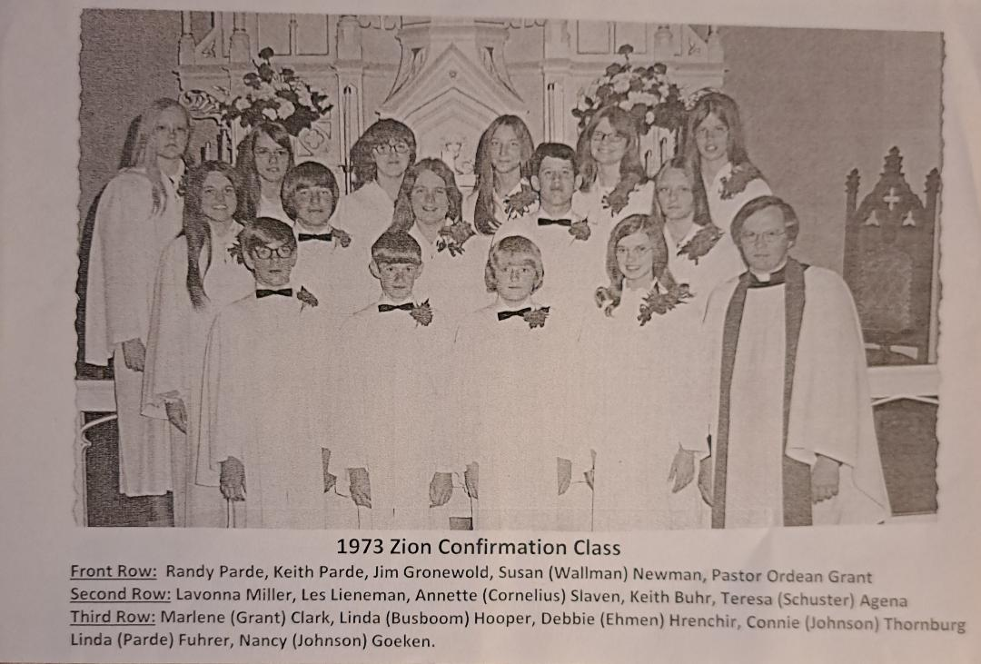

Last Call for the Photo Directory before printing now in June.

If you would like your picture in the printed photo directory, please notify Karen in the Church office so we can get you added. Also, if you haven’t had time to check your information (address, phone numbers, emails, birthdays, etc.) please go online to instantchurchdirectory.com and check it out. This is a neat program that Carrie Reed found; the online version will always be able to be updated! We are getting quotes for the price of printing the directories and if you are interested in a printed version there is a sign-up sheet on the Welcome Center or call Karen and let her know and she will get you added to the list. Thank you for all the work put into the directory by Carrie Reed, Rhonda Dorn and Brenda Gronewold.
JUNE 2023
 |  |  |  | 1  8:30-11:30 VBS K-5th grade. | 2  8:30-11:30 VBS Pre- school - 5th grade.  NE Synod Assembly | 3  NE Synod Assembly
4  10 am Worship/  Communion  VBS Program & Picnic to follow.  5 pm Zion t-ball vs Adam’s 5 | 5  7 pm Adams Silver 14 boys vs Shelby/Rising City | 6  Text Study | 7  Devotions – 7:00  Committees – 7:05  Council – 7:30  7 pm Adams Silver 14 vs Cresco White | 8  Adams Blue 10 Girls vs Fairbury | 9  5:30 pm  Wedding Rehearsal | 10  4 pm Mason/Hovendick  Wedding  Pickrell Days
11  9 am Worship/coffee fellowship by Grace Circle  5 pm Zion t-ball vs Adams 2  Pickrell Days | 12  7 pm Adams Silver 14 boys vs Garland Black | 13  Text Study | 14  1:30 pm Grace Circle | 15  Ladies Aid | 16 | 17
18  Father’s Day  9 am Worship/coffee fellowship by the hospitality committee  5 pm Zion t-ball vs Adam’s 6 | 19  7 pm Adams Silver vs Beatrice Pumas | 20  Text Study | 21  7 pm Adams Silver 14 boys vs Milford Purple | 22  **Deadline for newsletter*** | 23  6 pm Wedding Rehearsal | 24  4 pm Theye/Roth Wedding
25  9 am Worship/baptism/  Coffee fellowship by Grace Circle  5 pm Zion t-ball vs Adam’s 1 | 26  Pastor and Karen on vacation | 27  Pastor & Karen on vacation | 28  7 pm Adams Silver 14 boys vs David City 2  Pastor & Karen on vacation | 29  Ladies Aid  Pastor & Karen on vacation | 30  Pastor & Karen on vacation | Pastor & Karen on vacation

Card Shower for Evelyn Meints 89th birthday May 27th.
Card maybe sent to her at:
Evelyn Meints
Homestead House
Room 25
Beatrice, NE 68310

Some of you may be getting this infor after May 27th but I bet Evelyn would still love hearing from everyone! Happy birthday sweet Eveyln!

Pickrell Picnic June 10 & 11 – check out the bulletin board in the
back of the Church for more specifics.

Saturday, June 10
One Hill of a Run - registration at 7:30 am
Kickball Tourney – 9 am
Sand Volleyball – 9 am
Pickrell Car Show – 9 am
Boutiques & more – 9-3
Tractor Trek & Show – 9:30 am
C&W Rollin Smoke & Catering 11-7
Poker Run – 12-2
Competitive Cornhole Tournament 3:30
Stein Holding Competition in the Park 3 pm
Dirty Boots Band 9 pm

Kids Activities
Fire Truck Rides 11:30- 1:30
Color da Clown 12-3
Little Tuggers Pull 1:30 reg, 2:00 start.

Sunday, June 11
Community Church Service 11 am – Led by Homestead Harmonizers
Windsor Loin Dinner – 12:00
Side X Side Farm Tour 1:30

Free Piano – Available to look at in the schoolhouse. You haul. Would like out ASAP. Send inquiries to Janet Harms at 402-673-4845 or Connie Thornburg at 402-673-3605.

SIMPLE GIVING!
Ronald McDonald Tab collection

Collection at Zion is located at the Welcome Center Desk. Funds received from the tabs help pay for electric & other house expenses.

The Willow Center, a Pregnancy and Family Resource Center in Beatrice,
Baby Bottle Fundraiser opportunity for the Willow Center goes until Father’s Day! A few bottles are still available in the Fellowship Hall. The Cash filled bottles can be returned back to the pickup location. More details in June newsletter.
Also have you guessed Zion’s “baby pic celebrities?” Look closely!

